Astroparticle physics #885
On quantization of electron dynamics in a stationary electromagnetic field without radiation and with radiation

V.A. VORONTSOV
National Research Nuclear University MEPhI (Moscow Engineering Physics Institute), Moscow, Russia
(vva@inbox.ru)

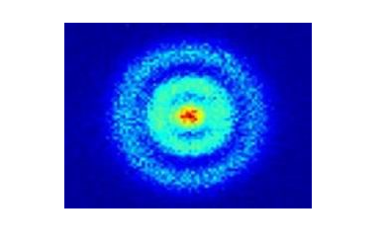
Picture 1. Experiment
The average orbits of many electrons in the nucleus ¹H
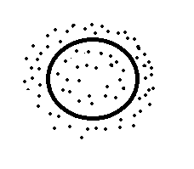
Picture 2. Calculation
In flat motion, the electron region is like a circle, whose center is moving along a circle of radius r_{B} ,
In volumetric motion, it is like a ball

