On quantization of electron dynamics in a stationary electromagnetic field without and with radiation
Vorontsov V.A.
National Research Nuclear Institute (Moscow Engineering Physics Institute)

Moscow, Kashirskoe Shosse, 31

vva@inbox.ru

Abstract
The movement of an electron in the nucleus field of a hydrogen atom consisting of one proton in a stationary orbit representing a circle is known to occur without radiation. The curvature of the orbit is determined by the action of the electric field of a practically fixed proton on a moving electron. A flat case is considered when the orbit circumference lies in a fixed plane of rotation. The trajectory of the electron is a broken line consisting of equal segments. The lengths of the segments are determined from the relation of uncertainties for the pulse and coordinates. The pulse is equal to the mass of the electron multiplied by the speed of light. It is assumed that the electron phase periodically transitions from state (E, t) to state (p, r). The increment of the pulse under the action of an electric field in the direction orthogonal to the electron pulse is equal to the quotient of dividing the Planck constant by the electron rest energy. Random component is excluded for simplicity. The trajectory of the electron turns into a polygon. The same approach was used to quantize the dynamics of the electron in the condenser. The radiation was simulated by turning the orthogonal pulse gain when it was rotated in a magnetic field, resulting in shortening of the electron pulse. This shortening led to the transition of part of the kinetic energy of the electron into radiation. Thus, it is shown that the given simplified quantization mechanism can be applied to electron dynamics, both without radiation and with radiation.

A group of scientists from Germany, Greece, the Netherlands, the USA and France received images of a hydrogen atom. In these images, obtained using a photoionization microscope, the electron density distribution is visible, which completely coincides with the results of theoretical calculations [1]. This method, described in 2004, was already used to obtain "photographs" of individual molecules, but physicists went further and used a photoionization microscope to study hydrogen atoms. Since the hit of one electron gives only one point, the researchers accumulated about 20 thousand individual electrons from different atoms and compiled an average image of electron shells. In accordance with the laws of quantum mechanics, an electron in an atom does not have any definite position on its own. Only when an atom interacts with the external environment does an electron with one probability or another manifest itself in some vicinity of the atom nucleus: the region in which the probability of detecting an electron is maximum is called an electron shell. The new images show differences between atoms of different energy states; scientists were able to clearly demonstrate the form of electron shells predicted by quantum mechanics. The result is shown on the Fig. 1

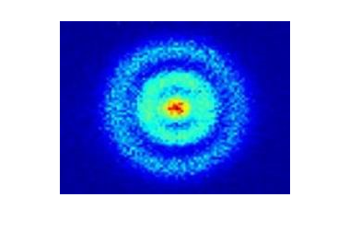
Figure 1. Experiment

The average orbits of many electrons in many hydrogen atoms

Consider the motion of one electron in a Borovian orbit, a radius of rB, which has a random component in motion. If we consider a flat motion without taking into account a random component, then its trajectory is a polygon on a plane. When introducing the random component along the radius r and azimuth ϕ and the binomiality of the distribution over these variables, the ratio of the numbers of deterministic and random jumps should be determined. The variance of the binomial distribution is Npq. With rB equal to 0.5 10⁻¹⁰ м, the number of deterministic jumps in the ND orbit will be about 120. Let's make estimates of the number of random jumps NR. . To do this, we calculate the relative speed β of rotation of the electron in the Borovian orbit. It's about 0.7 10⁻². Then the total number of random jumps N/β is equal to 2 10⁴ . We will consider uniformity of their dispersion in three directions r, ϕ, ψ. However, directions due to the quantization of the field are not random. Random is the number of jumps for each of them. And it will be approximately 6 10³. The geometric shape of the electron propagation in the Borovian orbit within one revolution corresponds to a torus of length 2π rB and a radius of cross section r⊥, determined from the ratio 2π rB π r⊥² = N/β *λ³, where λ = hc/mc2. In this case, r⊥ is equal to 1.5 10⁻¹¹ m. This is about a third of rB. Taking into account the motion along the a torus turns into a spherical layer 2/3 rB thick, which roughly corresponds to the theory and experiment conducted. The results of the simulation are shown on Fig. 2

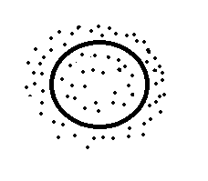

Figure 2. Calculation

In flat motion, the electron region is like a circle, whose center is moving along a circle of radius r_{B} ,
In volumetric motion, it is like a ball. After many revolutions, the ball turns into a spherical layer.

Conclusion

Thus, it is shown that the given model of motion of one electron with separated deterministic and random movements during estimates and simulations gives results close to experimental results for the averaged shells of many electrons supporting the theory.

References

[1] https://lenta.ru/news/2013/05/27/atom/

