Gravitation and cosmology #802
About the possible nature of dark matter and dark energy
V.A. VORONTSOV
National Research Nuclear University MEPhI (Moscow Engineering Physics Institute), Moscow, Russia
(vva@inbox.ru)

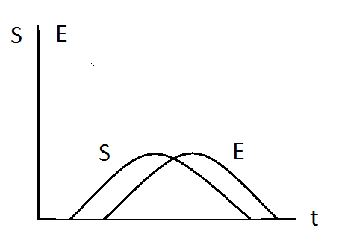
Picture 1. Density and order of system S and environment E versus time

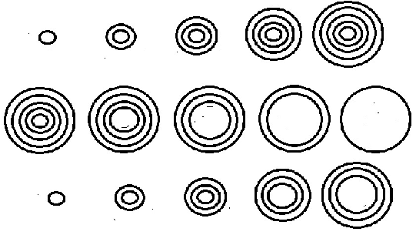

Picture 2. a) System expansion to saturation, DM.
b) Decay of the system due to the comfort of the environment and its junk, DE
c) Expansion of the system with simultaneous decay from the inside, DM & DE.

