About the possible nature of dark matter and dark energy
Vorontsov V.A.
National Research Nuclear University (Moscow Engineering Physics Institute)

Moscow, Kashirskoe Shosse, 31

vva@inbox.ru

Abstract

Known ideas about the dark matter and dark energy are based on the behavior of particles in a cosmological vacuum. There are searches for particles that make up dark matter. These include axions, neutrinos, WIMP particles. Gravitation is explained by the law of universal gravitation. Repulsion of particles is not clear. The nature of repulsive forces is unclear. The cosmological vacuum is represented as an environment in which there are both real and virtual particles. Unlike attempts to represent dark energy and dark matter in the form of individual particles with their subsequent search, a systematic approach was chosen to analyze the behavior of dark matter and dark energy in the work, describing the interaction of the system with the environment. It is assumed that some properties of matter are uniform in living and non-living. A certain analogy of the struggle for existence from the living world has been taken. The system fights the environment for space and time. As a system, for example, you can consider a black hole, and a cosmological vacuum as a medium. A streaming model was selected to consider how the system interacts with the environment. It contains flows of ordinary matter, as well as flows in the form of dark matter and in the form of dark energy, both the movement of the field and the movement of the vacuum, as types of movement of matter

Well-known ideas about dark matter and dark energy are based on the behavior of particles in a cosmological vacuum, outlined by V.A. Rubakov at the Research Institute of the Russian Academy of Sciences in the work Mysteries of the Universe [1]. There are searches for particles that make up dark matter. These include axions, neutrinos, WIMP particles. The 2020 Nobel Prize in Physics was awarded for the study of black holes. The award was received by Roger Penrose, Reinhard Genzel and Andrea Gea. [2]. However, the results of the work of Laura Mersini-Houghton, who discovered the drain of galaxies from the Universe and the formation of blue lakes in it, refute their existence [3]. Gravitation is postulated by the law of universal gravitation. Repulsion of particles is not understandable.. The resulting cosmological vacuum is represented as an environment in which there are both real and virtual particles.

Unlike attempts to represent dark energy and dark matter in the form of individual particles with their subsequent search, a systematic approach was chosen to analyze the behavior of dark matter and dark energy in the work, describing the interaction of the system with the medium [4].

As already mentioned, some properties of matter are the same or close to the living and non-living. In particular, this is a struggle for space and time of existence. A certain analogy of the struggle for existence from the living world has been taken. The system struggles with the environment for space and time. As a system, for example, you can consider a black hole, galaxy, star in the environment from a cosmological vacuum, field, dark matter. The interaction of the system and the environment is carried out within the framework of a streaming model describing different flows of moving and interacting matter.
The gravitation field sent to the vacuum by its source results in counter displacement of the vacuum. The source of the gravitation field projects in the form of a system, and the vacuum surrounding it is a medium. The medium entering the system is transformed, creating new connections in the system and compensating for existing connections that break down during the internal movement of the system and leave unused residues or debris that are withdrawn from the system. At first, the system grows, its expansion and the transformation of the internal environment into a more comfortable one for the system. As the comfort of the internal environment increases, the internal connections of the system begin to collapse and its growth slows down. The system enters a balance or equilibrium state with the medium.

Further improvement of the comfort of the internal environment leads to the destruction of the system connections and the beginning of chaotic scattering of parts of the system. This can be identified with the transition of gravity to anti-gravity and the appearance of dark energy instead of dark matter. Another reason for the scattering and crushing of parts of the system is the accumulation of debris inside it. The above mechanism of scattering or pushing parts of the system is qualitative without spatial and temporal estimates. He only explains in a certain way the transition of gravity to anti-gravity and the replacement of the tightening and growth of the system by the pushing and decay of the system. Thus, the order of the system is born in the fight against environmental chaos. The system is growing in space and time. Then, as the comfort of the internal environment of the system increases, there is a balance between the interaction of the system and the external environment and stopping the growth of the system. Then comes the period of destruction of the system, scattering of its parts due to increased comfort of the internal environment and accumulation of debris in the system.. Thus, the system is born in chaos and goes into chaos, renewing it. From the updated chaos, an updated system is born.

And again, the interaction of the system - environment is considered. The role of the system is to reduce chaos and increase order and, as a result, reduce the energy of its elements. The field pulls up the environment. The system is growing and its elements are updated, which can be called repairs. The comfort of the environment for the system, which is reduced to building an order convenient for the system in it, increases and the system begins to decay, losing order due to the comfort of the environment and the accumulation of unnecessary residues. There is an analogy from the outside world. Elements of the system lose unnecessary, limiting their freedom of communication due to the supercomfortness of the medium and the presence of unnecessary residues in the form of debris. A scattering system in such conditions is a manifestation of the presence and action of dark energy. The black hole is probably de Sitter's world. The behavior of dark matter and dark energy locally and counter. The thermal radiation of a black hole can be the ejection of waste material. Then, for example, the emergence of a black hole is a consequence of the struggle against the environment for survival.

Then the black hole grows, pulling the medium into the system and using it to line the necessary black hole order, pulling matter into the ball. Dark matter is the environment of a black hole, due to the tightening of the cosmological vacuum by the flows of its gravitation field. Further, saturation of the black hole, increased comfort of the internal environment, the onset of some kind of equilibrium and balance of flows. Then, in conditions of supercomfort of the internal environment, the beginning of separation of elements, destruction of the order of the system, an increase in chaoticism and scattering of the system elements due to an increase in the sludge inside and an increase in the comfort of the medium on the periphery. The work describes only possible mechanisms for the interaction of the system and the environment without quantifying time and space using the example of a black hole. So, the black hole is the emergence of order as a result of the fight against chaos, its expansion with pulling in and the necessary ordering of the cosmological vacuum. Further, improving the comfort of the internal environment and gradually slowing down the growth of the system. Then the onset of a balance of material flows into and out of the black hole. A further increase in the comfort of the internal environment and the accumulation of unnecessary residues, which causes the destruction of the system, its decay into elements and their scattering in the direction of better living conditions.

This can be a manifestation of dark energy, manifested in the movement of the decaying remnants of the system in the direction of greater comfort and deliverance from unnecessary junk. Dark energy is the scattering of the remains of the system in the direction of greater comfort of the environment and removal from the debris.. The system is born in chaos and goes into chaos, renewing it. From the updated chaos, an updated system is born and the story is repeated. The system is born in chaos and goes into chaos, renewing it. From the updated chaos, an updated system is born.

These processes are schematically shown in Figure 1. It is shown how the system S increases first, which draws in and uses medium E. Then saturation occurs, supercomfort occurs, the system stops growing and begins to collapse. The environment, however, continues to draw in and increase its order.

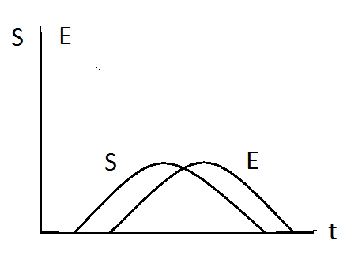

Figure 1. Change the density and order of system S and environment E versus time

Figure 2 shows different cases of growth and decay of the system and its environment.
So in Fig. 2. a) The birth of the system from the environment is depicted. At the end, the saturation and comfort of the environment continues to grow. This leads to the beginning of the decay of the system due to the increased comfort of the internal environment. Medium elements lose connections and begin to scatter from the center. Together with them, the system-ordered environment disintegrates.
Figure 2 (c) shows a case where the system is already starting to run from the inside during the growth process, although it continues to grow from the outside
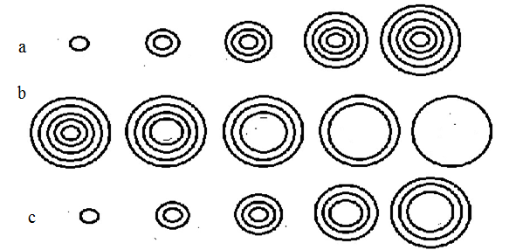

Figure 2. a) extending the system to DM saturation.
b) decay of the system due to the comfort of the environment and its sludge DE
c) system expansion with simultaneous decay from inside DM & DE

Conclusion
It was shown, that not only physical reasons can be used to explain the physical phenomtna

References

[1] https://clck.ru/RFNJs
[2] https://clck.ru/RFW5J
[3] https://www.astronews.ru/cgi-bin/mng.cgi?page=news&news=6558
[4] https://clck.ru/FbRUh

